Ch. 5 Geomcast Topic: Composition Transformations

Explain to the class how to complete the composition of transformations:
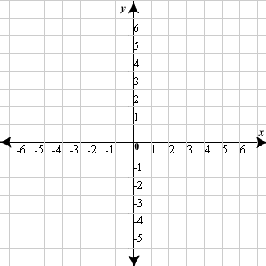
The vertices of ΔABC are A(2, 4), B(7, 6), and C(5, 2). Graph the image of ΔABC after a composition of the transformations in the order they are listed. Be sure to list the vertices after each transformation using proper notation.
Translation: (x, y) → (x – 2, y)
Rotation: 90° counterclockwise about the origin

