Ch. 7 Geomcast Topic: Right Triangles
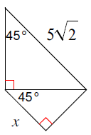
Solve for x:

