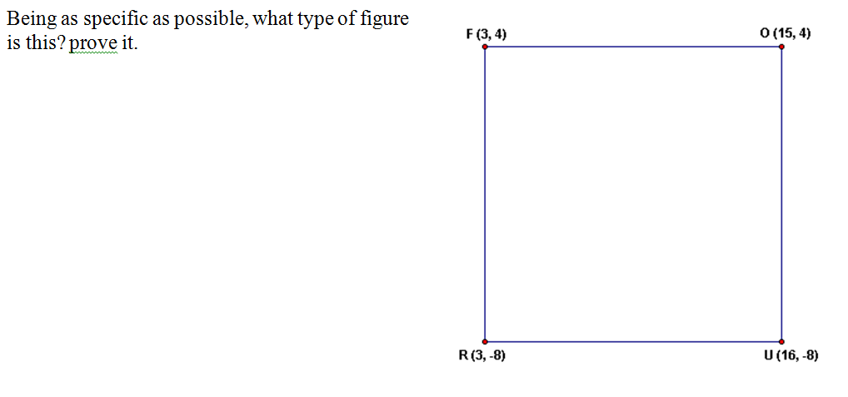
Ch. 8 Geomcast Topic: Proving type of Quadrilateral by Coordinate Proof

